**Monte Carlo Simulation in Goal-Based Investment of Retirement Plan**

**CHENG, Fangbei（20641288）**

**LI, Xinyi (20636398)**

The deterministic life-cycle investing with predefined change rate from one asset class to another is imperfect, for it fails to adequately account for lots of uncertainty in the optimal stochastic investment. Key variables that cause the variance of the life-cycle investment for a retirement plan mainly includes:

1. Expected return, volatility, and correlation of Investment returns

2. Inflation rates

3. Annual spending in retirement

4. Expected life span

5. Black swan events, which is hard to predict, such as financial crises, coronavirus pandemic, wars, etc.

6. Model error from incorrect estimates and assumptions

7. Other changes, like changes to Social Security, income tax rates etc.

In this project, we will employ Monte Carlo simulation to estimate portfolio returns in inflation indexed lifetime investment with two cases. In case 1, we will explore how Monte Carlo simulation is used to model uncertainty in retirement plans. In case 2, we will design a real-life case of goal-based life cycle investment for new graduates under different scenarios.

**Case 1**

First, we will use a subset of the time span in our investment to demonstrate how the Monte Carlo method models volatility drivers and project the likelihood of achieving financial goals.

Underlying assumptions for these calculations typically include:

1. Starting Age: 50

2. Retirement age: 60

3. Initial Portfolio value: $500,000

We select 5 assets: Treasury Notes(IEF), Treasury Bonds(TLT), the S&P 500(IVV), commodities(GLD), and Emerging Market Stocks (EMB). We use mean variance optimization (lambda=0.5) to estimate the portfolio weights. The Optimal portfolio has the following allocations: 21.38% in Treasury Bonds and 78.62% invested in S&P 500. The annualized expected return is 12.1% and standard deviation is 10%. The estimates of expected return and volatility (standard deviation) are shown in Table 1. Correlations of the asset classes can be found in Figure 1.

**Uncertainty 1: Uncertainty Around Investment Returns**

Assuming the returns of the investments follow a normal distribution and are correlated to each other, we use cholesky decomposition to generate sequences of correlated random numbers so that the simulation paths reflect the historical correlation between the assets.

We use Monte Carlo Simulation to run 5,000 simulations of the optimal portfolio. The expected return is formed by many potential outcomes. As is shown in Figure 2, the median wealth over time is indicated as the blue line in the graph, and shaded area is the 5th and 95th percentile wealth, through which we can see how much variation affected by uncertain returns in the portfolio.

**Uncertainty 2: Uncertainty Around Inflation**

We assume inflation rate is a normally distributed variable. The expected value of inflation rate is 3% and standard deviation of inflation rate is 1%. Different inflation rates result in significant variation in outcomes, as shown in Figure 3. In Figure 4, we also included the no inflation case (the green line) to show how our estimate of inflation negatively impacts wealth.

**Uncertainty 3: Uncertainty Around Living Expenses and Age of Death**

We checked the situation of different living expenses, $50,000 and $70,000 respectively. As shown in Figure 5, we end up running out of money in 52.66% of the simulations when we spend $70,000 annually, while the failure rate is 14.4% when spending $50,000. The wealth distribution in Figure 6 also plots the difference.

Also, we want to find how age of death impact our plans. We assume the death age be older, supposing that we live longer by 5 years and dead at 90, the median wealth indicates that there is a higher probability that we end up running out of money, as demonstrated in Figure 7.

**Case2:**

Have learnt the core theories about Monte Carlo simulation, now we want to design a retirement goal based portfolio for ourselves. And the plan is that:

1. At age of 25, we invest $10000 to build the initial portfolio.
2. The asset class includes:

|  |  |
| --- | --- |
| Ticker | Asset |
| IVV | iShares Core S&P 500 ETF |
| VEA | Vanguard FTSE Developed Markets ETF |
| IEF | iShares 7-10 Year Treasury Bond ETF |
| TLT | iShares 20+ year Treasury Bond ETF |
| TIP | iShares TIPS Bond ETF |
| EMB | iShares JP Morgan USD Em Mkts Bond ETF |
| HYG | iShares iBoxx $ High Yield Corp Bond ETF |
| GLD | SPDR Gold Shares |
| RWX | SPDR Dow Jones International Real Estate ETF |
| SHY | iShares 1-3 Year Treasury Bond ETF |

1. We assumes the retirement age is 60, and from age 25 to 60, each year we contribute $6000 with an incremental rate 3% into the portfolio.
2. During different life periods, we also have different financial goals:

|  |  |  |
| --- | --- | --- |
| Age 25-35 | Travel | $1000/year |
| Credit card repay | $1000/year |
| Age 35-60 | Education | $4000/year |
| Housing loan | $4000/year |
| Medical expense | $2000/year |
| Age 60-85 | Percentage Withdraw | 3% |

So then, we implement Monte Carlo simulation to help us design financial plan in order to meet those goals with high probability. The tool we used is [portfolio visualizer](https://www.portfoliovisualizer.com/).

* **Implementation**

Firstly, based on above information, we consider the following input parameters before conducting Monte Carlo Simulation.

**Initial and retirement portfolios**

The initial portfolio is an aggressive one and retirement portfolio is a conservative one. So when optimize these two portfolios, we consider the start one is more risky than the end one. And here is the asset allocation for different risk level.

|  |  |  |
| --- | --- | --- |
| Ticker | Initial | Retirement |
| IVV | 6% | 3% |
| VEA | 4% | 3% |
| IEF | 12% | 8% |
| TLT | 7% | 3% |
| TIP | 11% | 9% |
| EMB | 6% | 6% |
| HYG | 8% | 6% |
| GLD | 5% | 3% |
| RWX | 4% | 3% |
| SHY | 37% | 56% |

**Simulation description**

1. Single year bootstrapping model is implemented for 60 years (25-85).
2. 10000 portfolios using available historical returns data from Jan 2008 to Dec 2019 are simulated.
3. The simulated inflation model used historical inflation with 1.70% mean and 1.32% standard deviation based on the Consumer Price Index (CPI-U) data from Jan 2008 to Dec 2019.
4. The generated inflation samples were correlated with simulated asset returns based on historical correlations.

**Simulation results**

1. **Portfolio success probability (figure 8)**

8439 portfolios out of 10000 simulated portfolios (84.39%) survived all withdrawals. 100% success probability lasts for 25 years. And starting from age 50 to retirement age, the probability gradually decreased to 87.6%. Seems in this time period, the education and housing loan withdrawals begin to challenge our portfolio. After retirement, the portfolio success probability keeps consistent at 87.6%.

1. **Portfolio balance (figure 9)**

The portfolio ended up being worth between $0 and $24,541, and the average end balance is $13,877. And in the first 10 years, our portfolio balance keeps increasing, that benefits from restrained consumption on travel and credit card. Starting from age 35, the portfolio balance gradually decreases. After retirement, the balance tends to be flat but slightly increases.

1. **Asset allocation glide path (figure 10)**

35-year linear glide path was used to transition from starting portfolio to retirement portfolio.

The changes in asset allocation are relatively intuitive. Every year we reduce the weight on each asset until it’s the same as the weight on retirement portfolio at age 60.

1. **Cash flow (figure 11)**

To survive this portfolio, the first 10 years are certainly stressful, cause we need to make sure an increasing cash inflows in the portfolio. Then, we may less concerned about the retirement life. Age 35-60 is a period when cash outflows are outstanding, it’s “painful” but under control. If we can follow the financial plans, the portfolio would still have a high survival probability.

* **Notes**

1. **Contribution with an incremental rate is needed for a success retirement portfolio.**

In this simulation, we set an each year contribution with a 3% incremental rate into the portfolio. But if we don’t require the contribution to increase each year, no portfolio would survive in the end.

1. **The years before retirement are significant.**

We tried some high withdrawal rate (i.e. 10%) after retirement, and the portfolio success probability is still around 85%. So it shows that a consistent contribution and reasonable financial goals would contribute to a comfortable retirement life.

* **Limitations and remedies**

The advantages of Monte Carlo simulation implementing in GBI is obvious. It gives a clearer picture of risk in whether investors will outlive retirement savings and a dynamic life-time asset glide path under different financial goals. However, this method has exposed some shortcomings.

1. **overly favorable assumptions**

Monte Carlo analysis cannot accurately consider infrequent but radical events, such as market crashes or financial crisis into its probability analysis. There's no guaranteed way to predict whether the market will perform as it did in any of the simulations. One simple way to remedy this idealized simulation is to minus a flat decrease to the possibility of financial success, such as 10% or 20%. It gives the investors a direct cognition of possible loss caused by unexpected events. In addition, if we encounter a poor set of economic circumstances, we can adjust the variables, such as below-average returns or above-average rates of inflation, to ensure the reliability of future projection.

1. **Rigid data distribution assumption**

For Monte Carlo analysis, data is generated based on some potential model features, such as mean and standard deviation, obtained from the historical actual value of the assets with the underlying assumption that the returns follow a normal distribution. This can’t be applied to all situations when the “tails” of the distribution are “fatter” than a normal distribution, particularly downside. To provide a reasonable output, Monte Carlo analysis can project more tail risk by not accounting for mean reversion, this can offset the lack of fat tails evident in the data.

1. **Strict input assumptions**

The output of Monte Carlo simulations are good only if the inputs they start with are also good. So the success possibility of the input determines the usefulness of the simulation. Which means, investors should strictly comply with the determined withdrawal plan, or else the simulations wouldn’t be trustworthy. To offset this impact, investors should make their financial goals more realistic and take all possible withdrawal situations into consideration. Other future work would include exploring impacts of Social Security and tax rates for a given retirement planning strategy.

**References**

EDHEC-Risk Institute Publication. 2010. New Frontiers in Benchmarking and Liability-Driven Investing.

Raghu Suryanarayanan, Ludger Hentschel, Giulio Panzano, Dan Schneider. 2014. Goal-Based Asset Allocation in WealthBench.

Michael McDonald, P., Recruiting, K., Wilkins, S., Lawline, S. and Recruiting, D., 2020. Finance And Law: The Pros And Cons Of Monte Carlo Simulations In Valuation. <https://abovethelaw.com/2016/05/finance-and-law-the-pros-and-cons-of-monte-carlo-simulations-in-valuation/?rf=1>

Investopedia. 2020. What Can The Monte Carlo Simulation Do For Your Portfolio?.

<https://www.investopedia.com/articles/investing/112514/monte-carlo-simulation-basics.asp>

**Appendix**

Table 1 Expected return and volatility (standard deviation) of Case 1 portfolio

|  |  |  |
| --- | --- | --- |
|  | expected return | volatility (standard deviation) |
| Treasury notes(IEF) | 4.58% | 5.88% |
| Treasury Bonds(TLT) | 8.31% | 13.25% |
| S&P 500(IVV) | 13.18% | 13.97% |
| commodities(GLD) | 3.25% | 14.78% |
| Emerging Market Stocks (EMB) | 5.91% | 7.57% |

Figure 1 Correlations of the asset classes

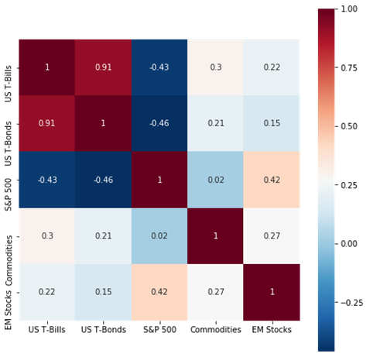

Figure 2 Uncertainty Around Investment Returns

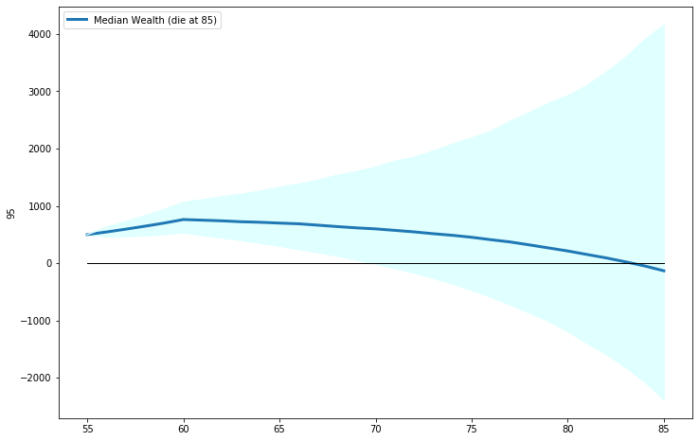

Figure 3 Uncertainty Around Inflation

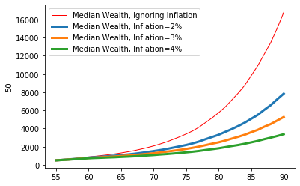

Figure 4 Uncertainty Around Inflation: negative impacts of inflation

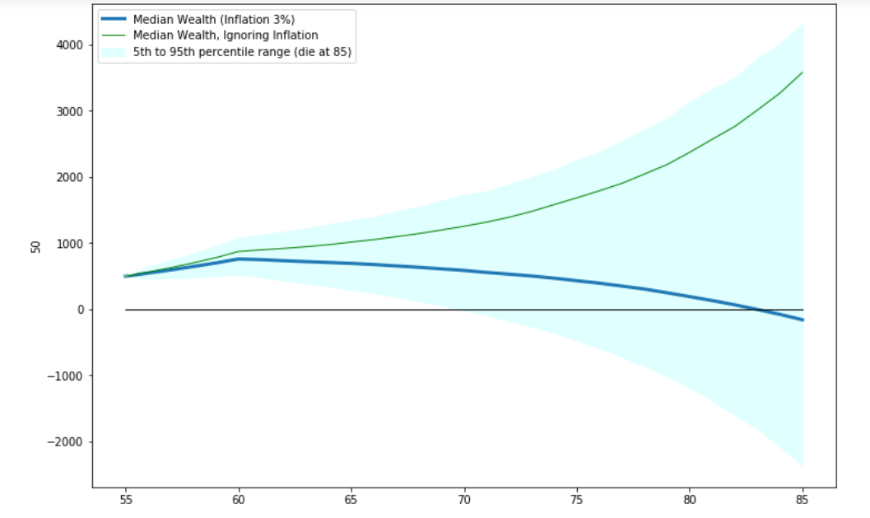

Figure 5 Uncertainty Around Spending

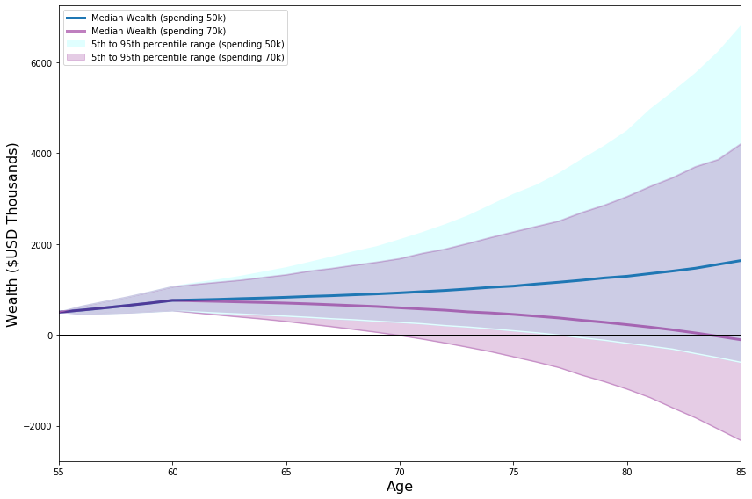

Figure 6 Uncertainty Around Spending histogram

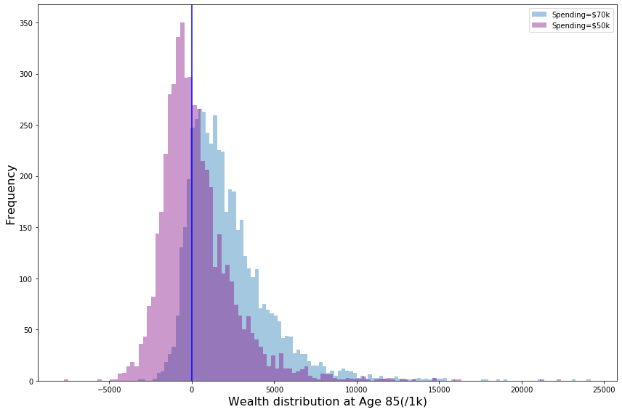

Figure 7 Uncertainty Around Age

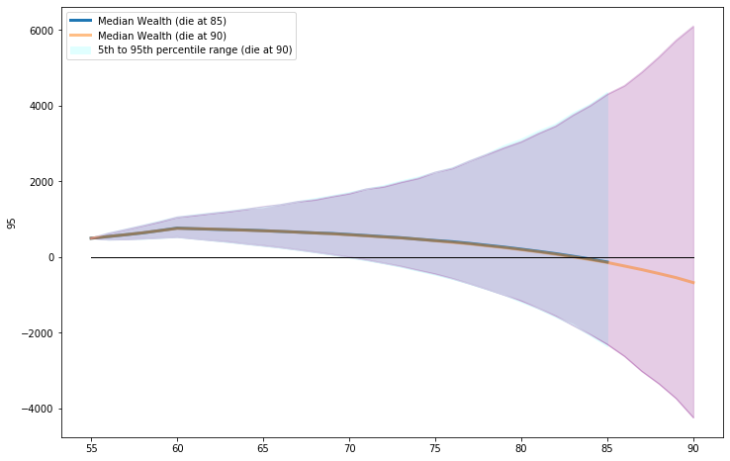

Figure 8 Portfolio success probability

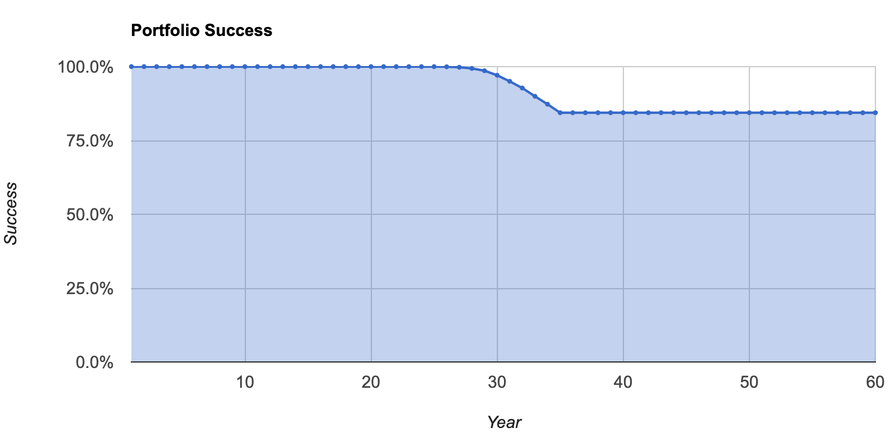

Figure 9 Portfolio balance

Figure 10 Asset allocation glide path

Figure 11 Cash flow

